Reddit is an online social platform, where users share, view, and discuss content in communities called subreddits. How do people generally allocate their energy on different communities? It turns out that someone prefers the way of a generalist, who spend their time on various topics through different communities, while some tend to be generalists, who focuses on highly concentrated and related fields. In the paper “Generalists and Specialists: Using Community Embeddings to Quantify Activity Diversity in Online Platforms”, methods have been proved useful in measuring users’ diversity of Reddit activity. While the study described in the paper is conducted on an extremely wide range of communities, it is also interesting to investigate user behaviors on a specific topical subset. In this project, we will focus on political subreddits.

We will mainly investigate on two research questions: Within the range of political subreddits, How many generalists or specialists are there, or does there tend to be more generalists or specialists? Secondly, how vulnerable are users to political echo chambers, or how much of such a pattern can we witness?

The dataset includes metadata for both comments and submissions (posts) on Reddit from January 2019-June 2021, including only a group of about 100 selected subreddits. As data unrelated to political communities do not contribute to our research, we will filter out any comment/submission that does not belong to a political subreddit. We come up with a subset of 7 political subreddits, manually - the entire set of subreddits is small enough to make it possible, and by doing so we’re achieving a higher classification accuracy than any other method. We then clean the data by filtering out the comments and submissions with nonsensical usernames to avoid biases.

To define user activity, we first want to produce a scale for community similarities. This is achieved using word embeddings from Word2Vec, with communities as words and users as contexts - intuitively, two communities are similar if they share a similar population of members. We use bi-grams with embedding size 20. With the results, we can introduce our activity measurement - a user is more of a specialist if it is active in similar communities. If we have the user’s contribution to community i w_{i} and the embedding vector c_{i}, then we are able to define the user’s mass as ∑w_{i}c_{i}. Then we can come up with a scale called GS-score, and we produce its definition as the average cosine similarity similarity between the user’s communities and its center of mass, weighted by its contributions to the communities.

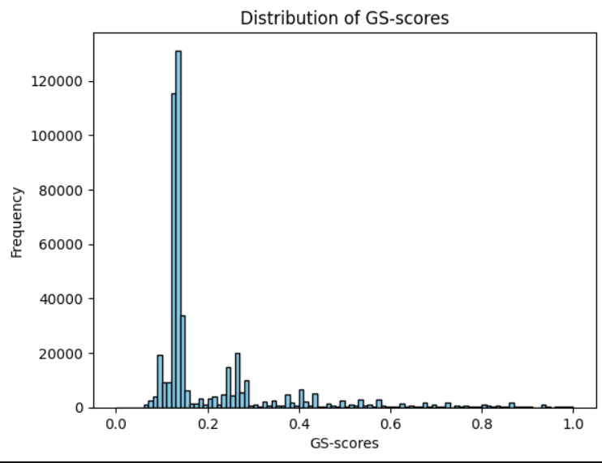
By plotting the GS-score distribution, we find that within our definition and in the range of political subreddits, most users are considered generalists - they are either active in many communities or in very different communities. The distribution seems to be extremely positively-skewed on the graph. This can be a result of our dataset choice, as the number of total subreddits is merely about 100 and that of political subreddits is as small as 7, each of which becomes distant/different from another. Thus, the result is quite susceptible to natural fluctuation.

With the GS-scores, we can also investigate on user interactions. A user interact with another user by reply the post/comment. If we say the user being replied is a contact of the replier, what is the tendency in the average GS-score of a user’s contacts, or parent universe? We find that the parent universe score of a generalist tends to be low, and vice versa. In other words, generalists have more generalist contacts, and specialist have more specialist contacts, which is a satisfying proof of the existence of political chambers.

Comparing the research results with the ones in the paper, some effects/phenomena are replicated in our study, while some are different, which might a consequence of the choice of some data handling process.

